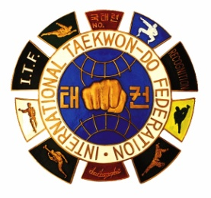
International Taekwon-Do Federation (I.T.F.)

Draugasse 3, 1210 Vienna, AUSTRIA
Tel: (+43-1) 2928467 | Fax: (+43-1) 292846789
E-Mail: secretary-gen@itfhq.org | director-af@itfhq.org
Website: www.itf-tkd.org

APPILICATION FOR OFFICIAL EVENT TO BE ENDORSED BY ITF

Organizer name:
Organizing NGB:
NGB Address:
Event name:

Event Conductor name:

Even Date: Event place:

ITF DB registration link:

Note on IIC/IUC/ITS

ITF HQs will deliver the prefix number of the IIC/IUC/ITS to the organizer one week before the course or the seminar.
Registration to all the events must be made through the ITF DB and only the Info-pack containing ITF DB registration link can be published in ITF website.

NGB President/ Authorized deputy:

Date: Signature:

(NGB stamp)

==========================================================================

(ITF use only)

Approved: Disapproved: Int’l Course/Seminar prefix number:

Remarks:

Date: Signature:

ITF Stamp

